**Experiment No.2**

**Aim:** To transfer 10 numbers of data from one memory location to another memory location.

**Code:**

data segment

; add your data here!

data1 db 00h,01h,02h,03h,04h,05h,06h,07h,08h,09h

data2 db 10dup(0)

ends

stack segment

dw 128 dup(0)

ends

code segment

start:

; set segment registers:

mov ax, data

mov ds, ax

mov es, ax

mov si,offset data1

mov di,offset data2

mov cx,0ah

l1:

mov al,[si]

mov bl,[di]

mov [di],al

inc si

inc di

loop l1

; wait for any key....

mov ah, 1

int 21h

mov ax, 4c00h ; exit to operating system.

int 21h

ends

end start ; set entry point and stop the assembler.

**Output:**

**Array before transfer**

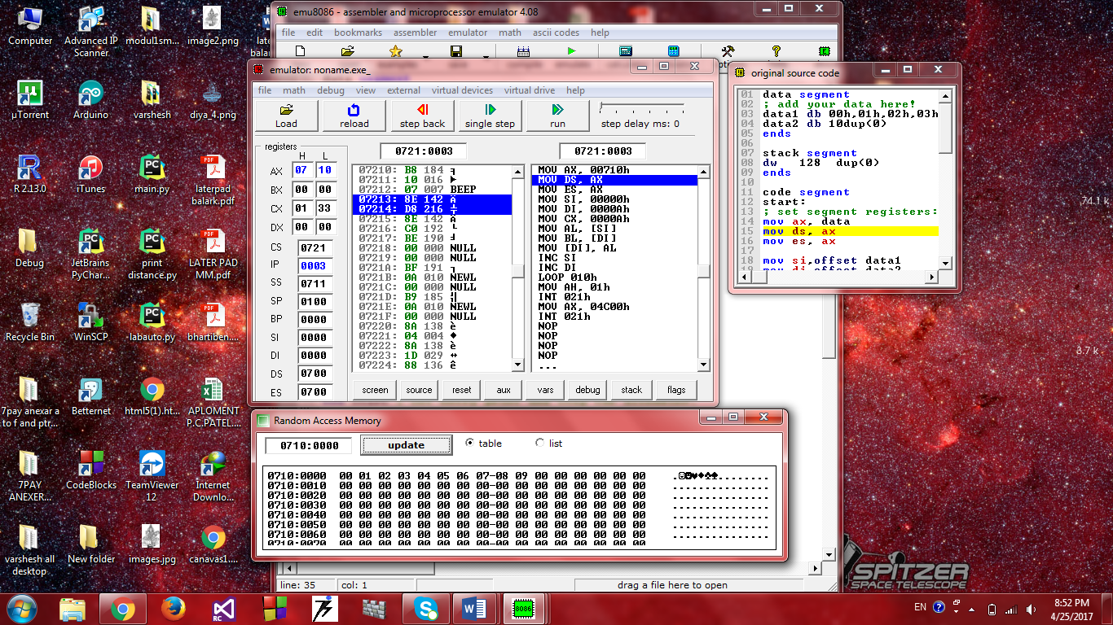

**Array after transfer**

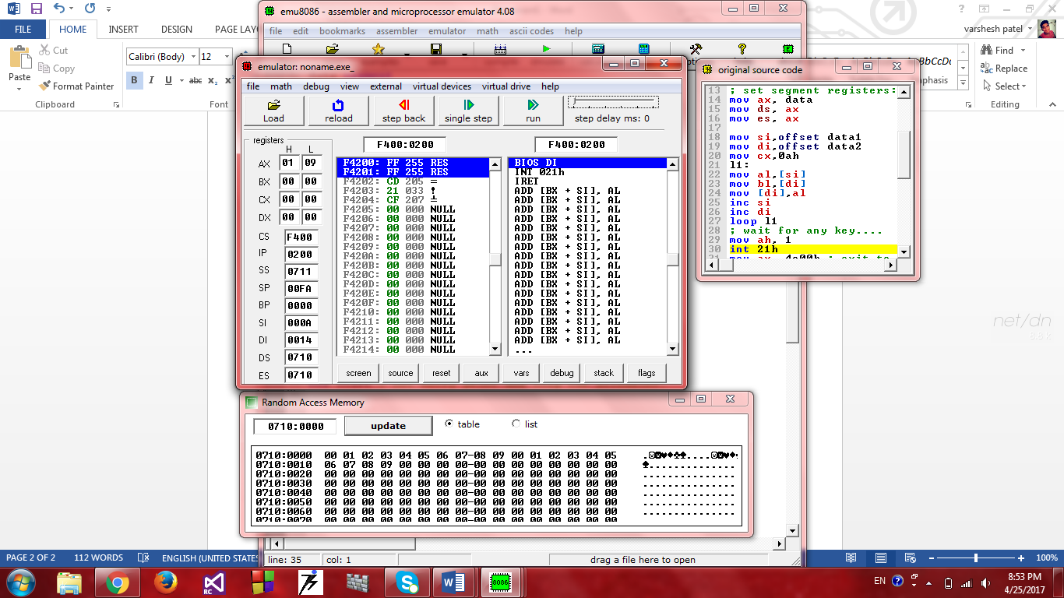



**Experiment No.3**

**Aim:** To change the order of a given array.

**Code:**

data segment

; add your data here!

data1 db 00h,01h,02h,03h

data2 db 02bh,02ch,02dh,02eh

ends

stack segment

dw 128 dup(0)

ends

code segment

start:

; set segment registers:

mov ax, data

mov ds, ax

mov es, ax

mov si,offset data1

mov di,offset data2

mov cx,05h

l1:

mov al,[si]

mov bl,[di]

mov [si],bl

mov [di],al

inc si

inc di

loop l1

; wait for any key....

mov ah, 1

int 21h

mov ax, 4c00h ; exit to operating system.

int 21h

ends

end start ; set entry point and stop the assembler.

**Output:**

Before order changed

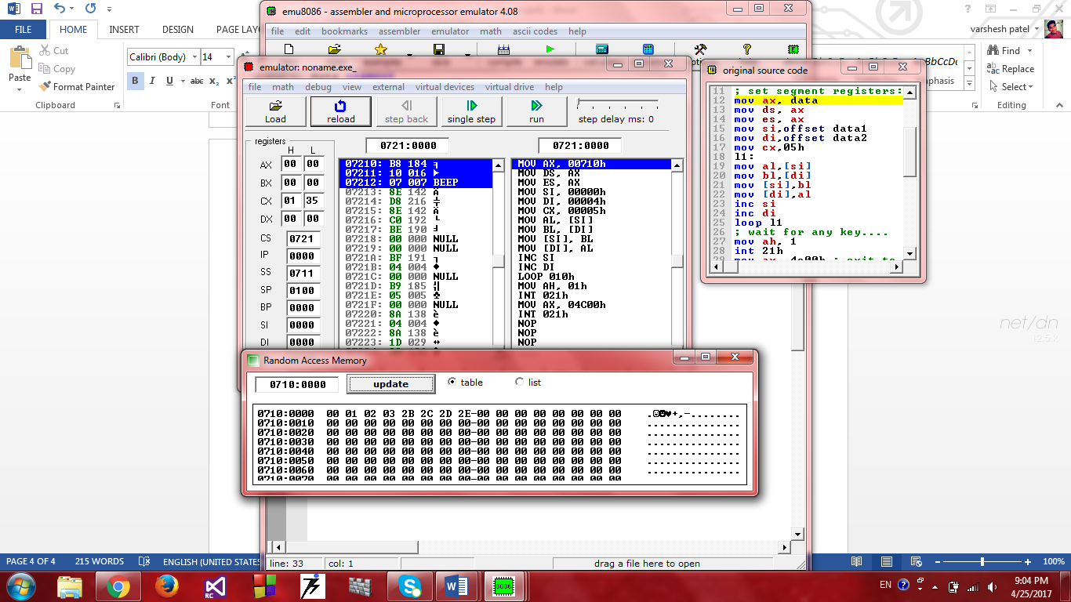

After order changed

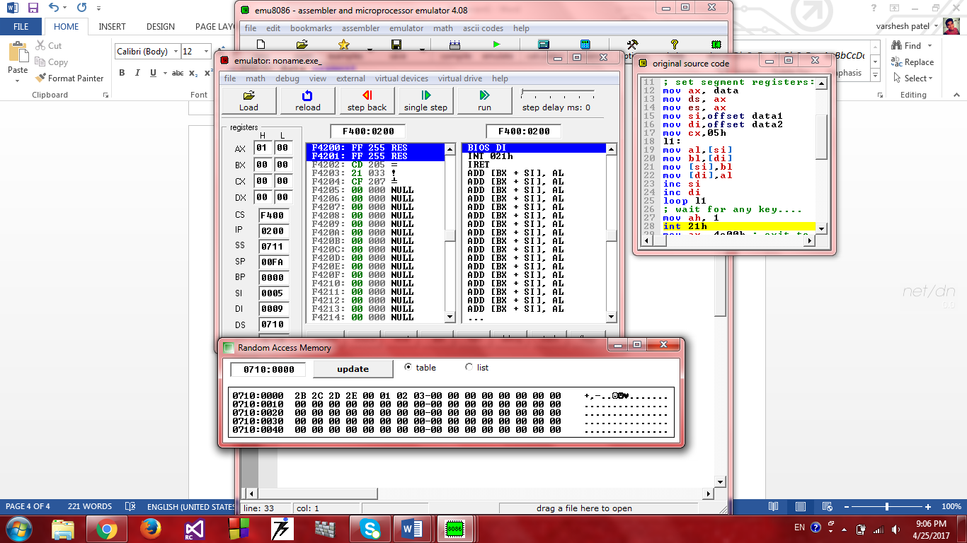

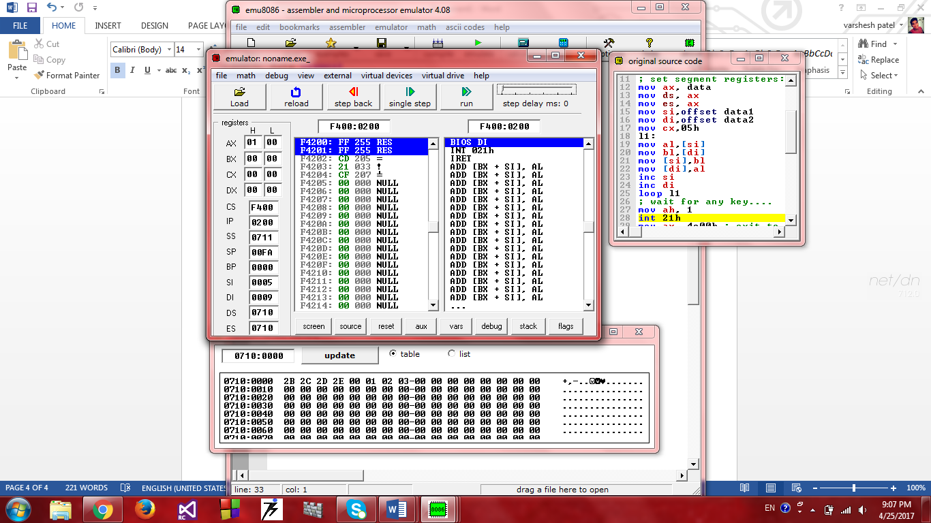

**Experiment No.4**

**Aim:** To add 2 8-bit numbers

**Code:**

data segment

a db 09h

b db 02h

c db ?

ends

stack segment

dw 128 dup(0)

ends

code segment

start:

; set segment registers:

mov ax, data

mov ds, ax

mov es, ax

mov ah,00h

mov al,a

mov bl,b

add al,bl

mov c,al

; wait for any key....

mov ah, 1

int 21h

mov ax, 4c00h ; exit to operating system.

int 21h

ends

end start ; set entry point and stop the assembler.

**Output:**

Data loaded into register

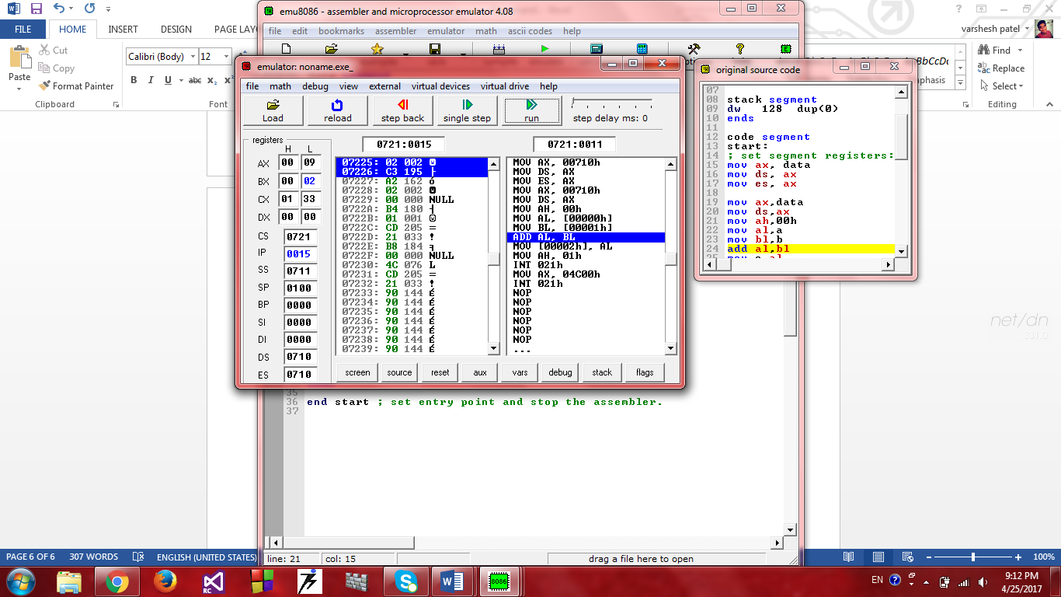

After add ,changed in ax->al->0B(add 09h,02h)

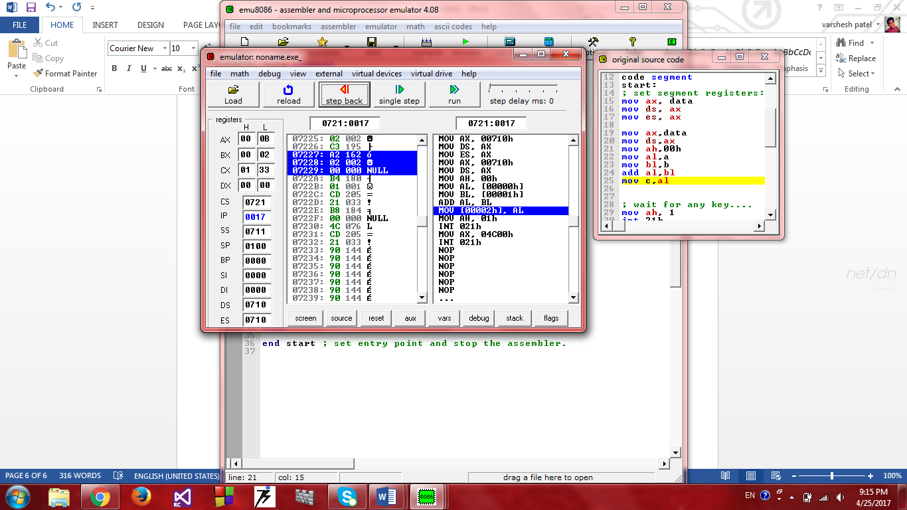

In memory

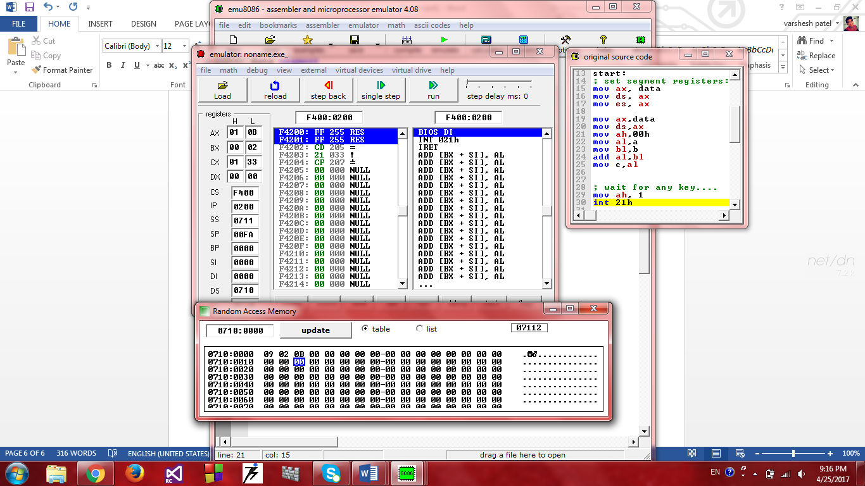

**Experiment No.5**

**Aim:** To multiply 2 8-bit numbers.

**Code:**

data segment

; add your data here!

a db 09h

b db 02h

c dw 00h

ends

stack segment

dw 128 dup(0)

ends

code segment

start:

; set segment registers:

mov ax, data

mov ds, ax

mov es, ax

mov ah,00h

mov al,a

mov bl,b

mul bl

mov c,ax

; wait for any key....

mov ah, 1

int 21h

mov ax, 4c00h ; exit to operating system.

int 21h

ends

end start ; set entry point and stop the assembler.

**Output:**

Data loaded in register

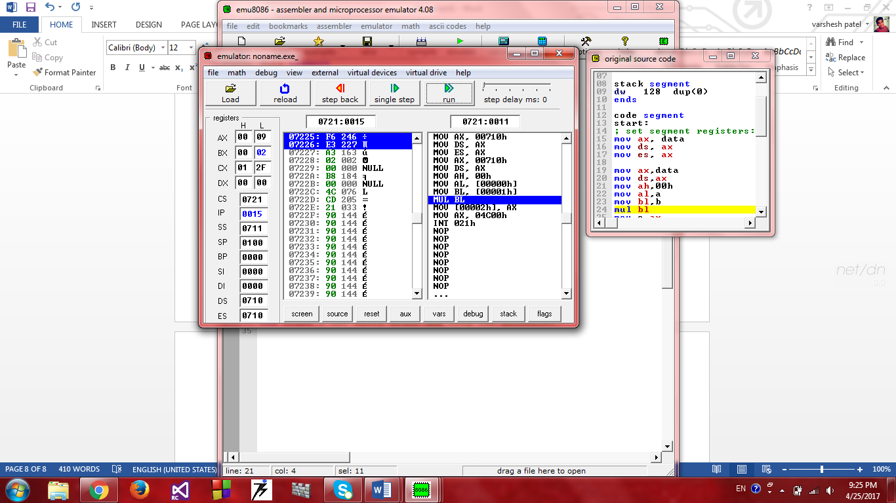

After mul, change in al and ax

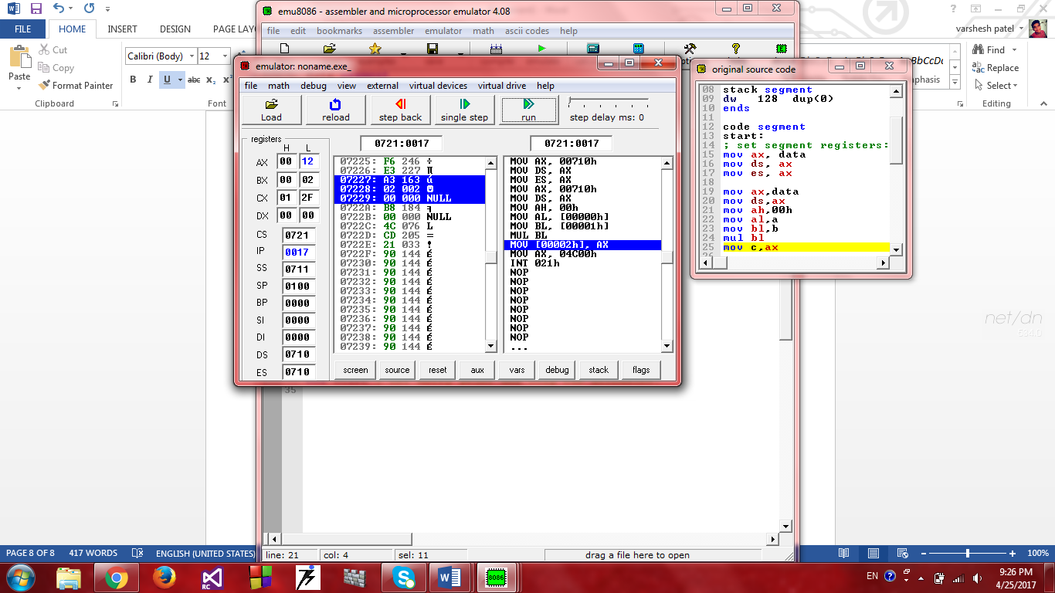

Data in memory

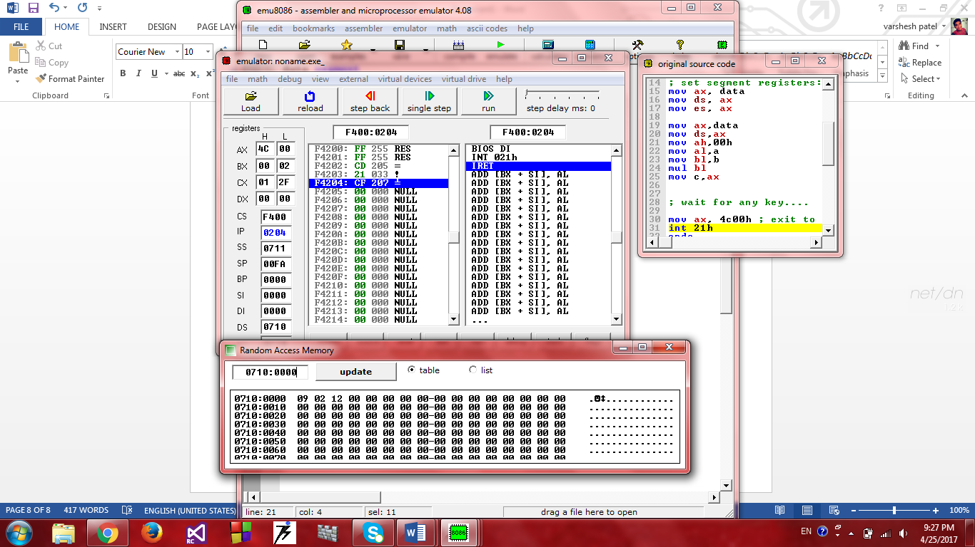

**Experiment No.6**

**Aim:** To find out the smallest number from given array.

**Code:**

data segment

; add your data here!

num db 0Fh,08h,14h,09h,05h

res db ?

ends

stack segment

dw 128 dup(0)

ends

code segment

start:

; set segment registers:

mov ax, data

mov ds, ax

mov es, ax

mov ah,00h

mov si,offset num

mov bl,[si]

mov res,bl

mov cx,05h

l1:

mov al,[si]

cmp al,bl

jge l2

mov bl,al

mov res,bl

l2:

inc si

loop l1

mov res,bl

mov ax, 4c00h ; exit to operating system.

int 21h

ends

**Output:**

Memory, before finding

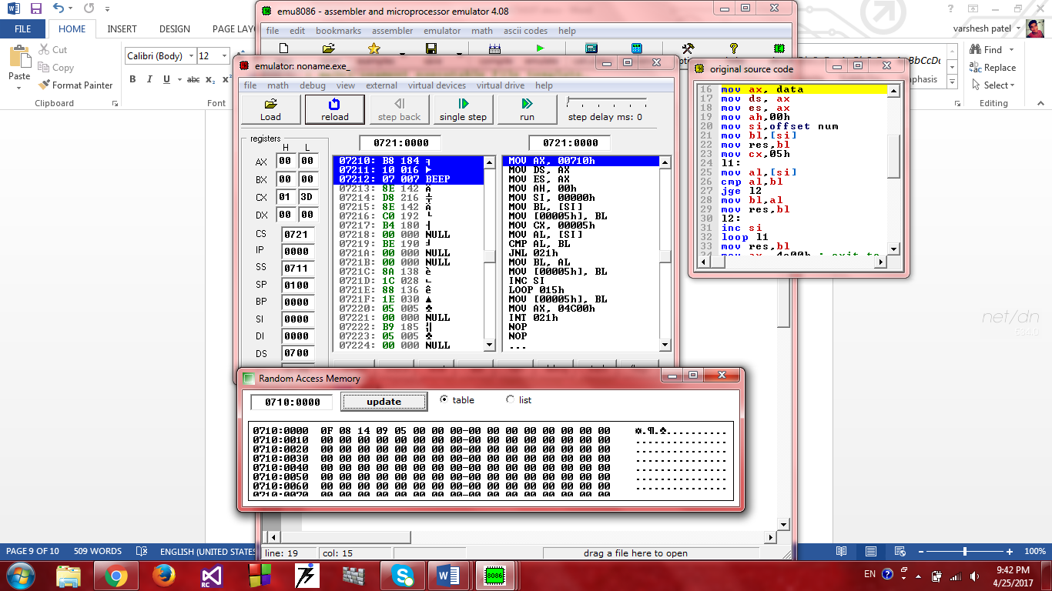

After finding smallest number from array in al

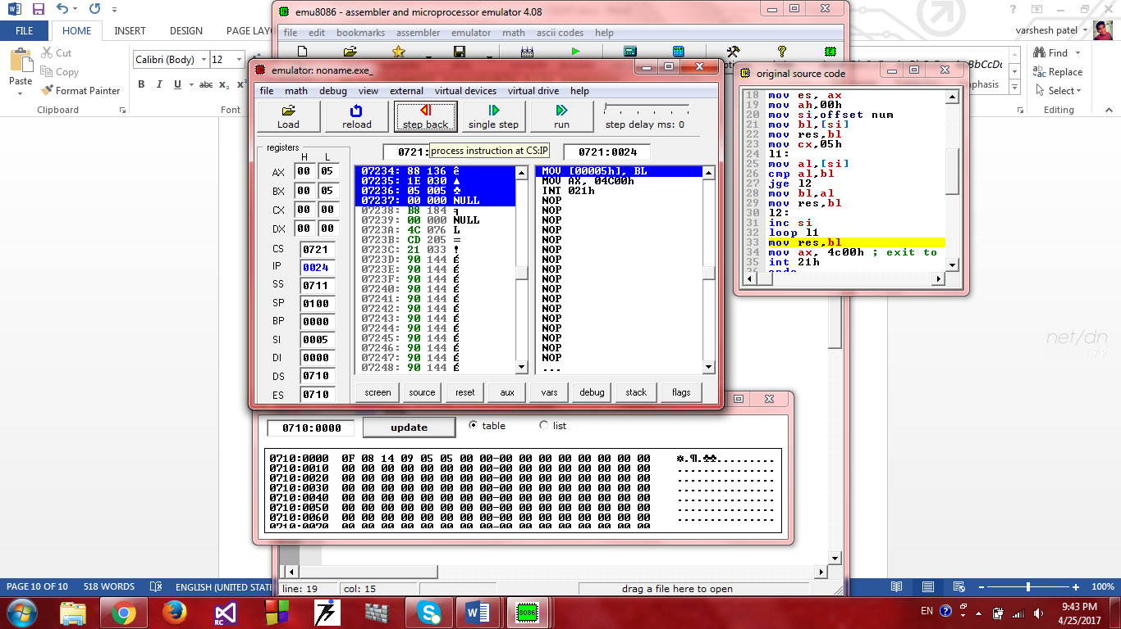

In memory



Last digit show smallest number

**Experiment No.7**

**Aim:** Find out Average number from given set of numbers.

**Code:**

data segment

; add your data here!

num db 0Fh,08h,14h,09h,05h

avg db 00h

ends

stack segment

dw 128 dup(0)

ends

code segment

start:

; set segment registers:

mov ax, data

mov ds, ax

mov es, ax

mov ah,00h

mov si,offset num

mov cx,05h

mov bl,00h

l1:

mov al,[si]

add al,bl

mov bl,al

inc si

loop l1

mov ax,bx

mov ah,00h

mov bx,02h

div si

mov avg,al

mov ax, 4c00h ; exit to operating system.

int 21h

ends

**Output:**

Memory before finding average

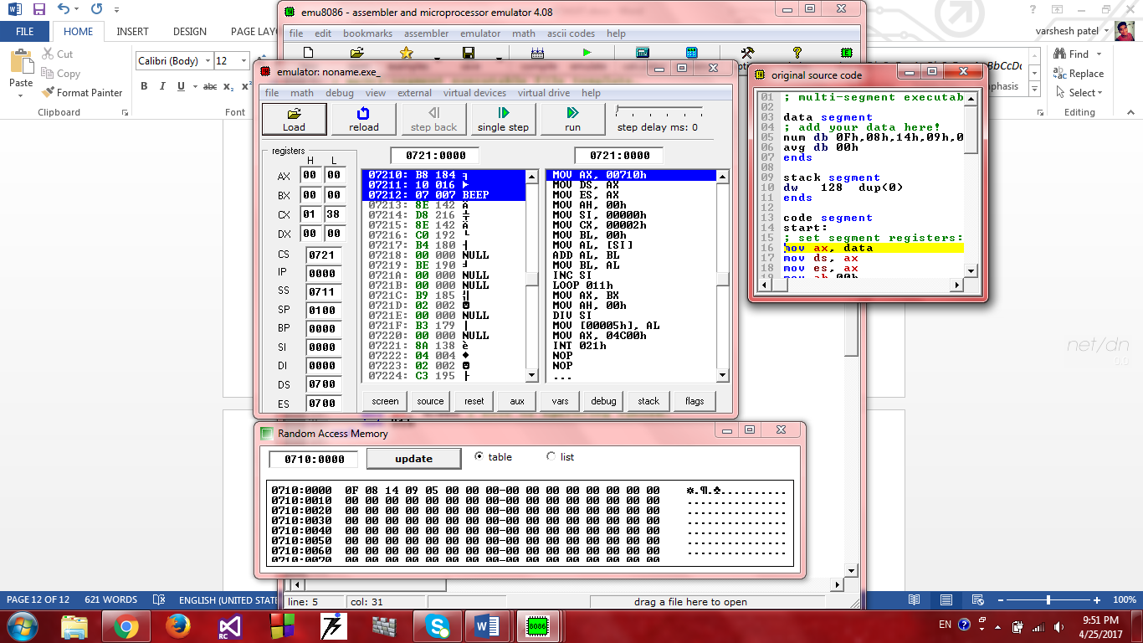

Last digits show avg

After find average

In registers

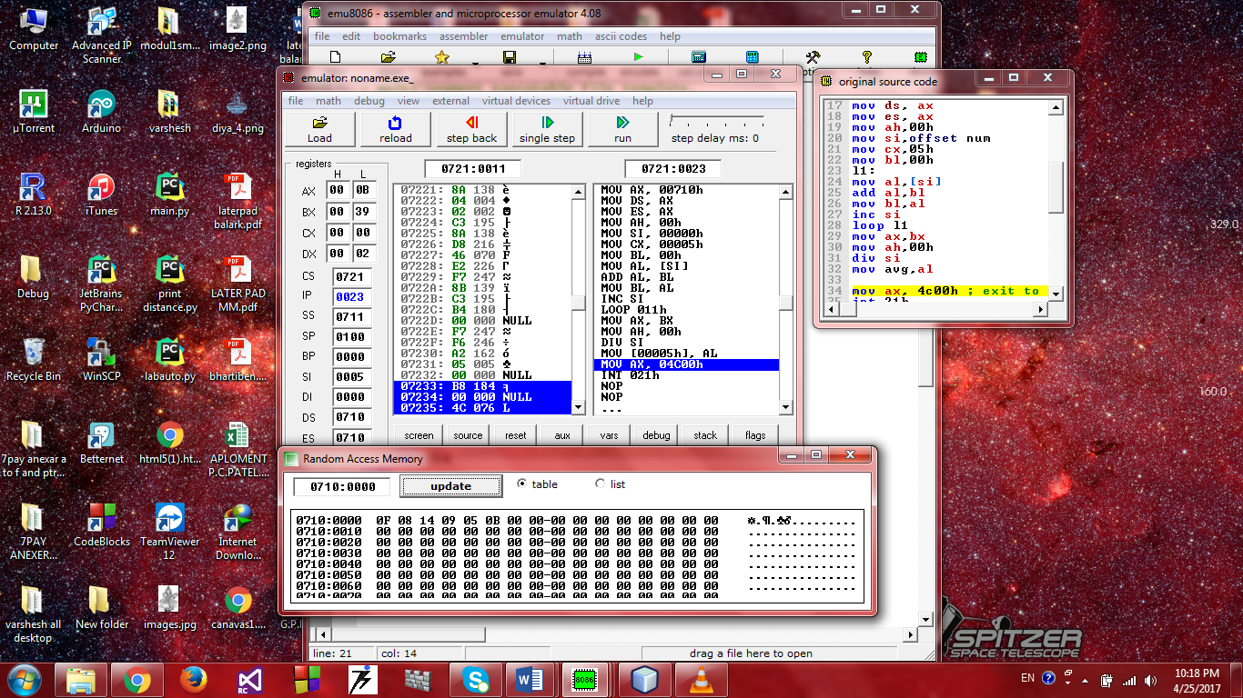

In memory



Last digit show avg

**Experiment No.8**

**Aim:** To arrange array in ascending order.

**Code:**

data segment

array db 0Fh,08h,14h,09h,05h

ends

stack segment

dw 128 dup(0)

ends

code segment

start:

; set segment registers:

mov ax, data

mov ds, ax

mov es, ax

mov ch,05h

UP2: mov cl,05h

mov si,offset array

UP1: mov al,[si]

mov bl,[si+1]

cmp al,bl

jc down

mov dl,[si+1]

xchg [si],dl

mov [si+1],dl

DOWN: inc si

dec cl

jnz UP1

dec ch

jnz UP2

; add your code here

mov ax, 4c00h ; exit to operating system.

int 21h

ends

**Output:**

Before ordering ,array in memory

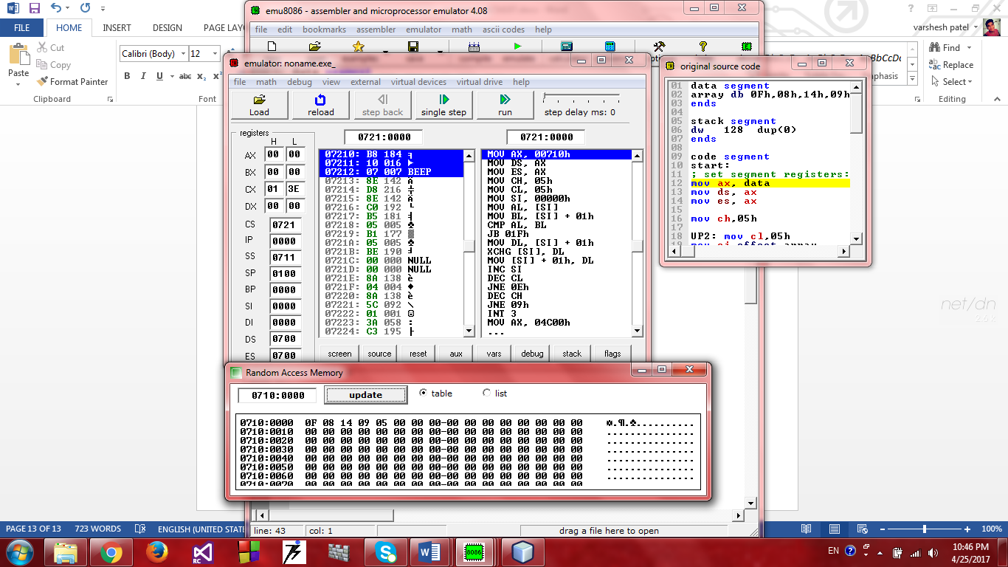

After order ,array in memory

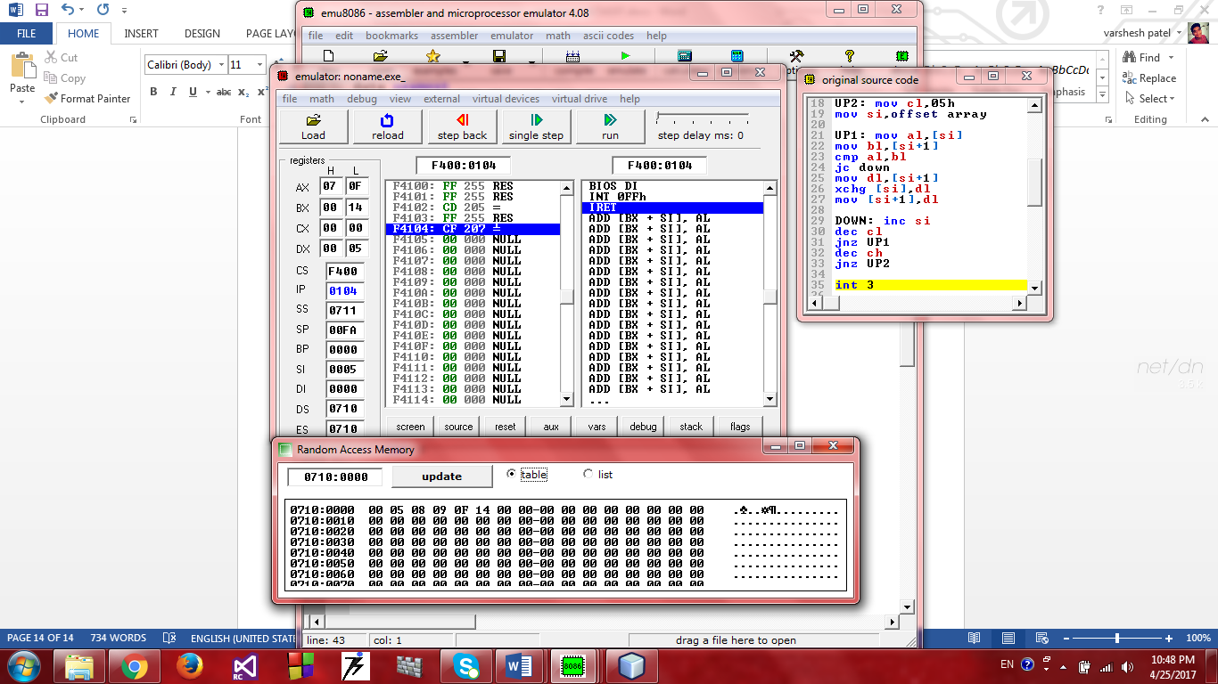

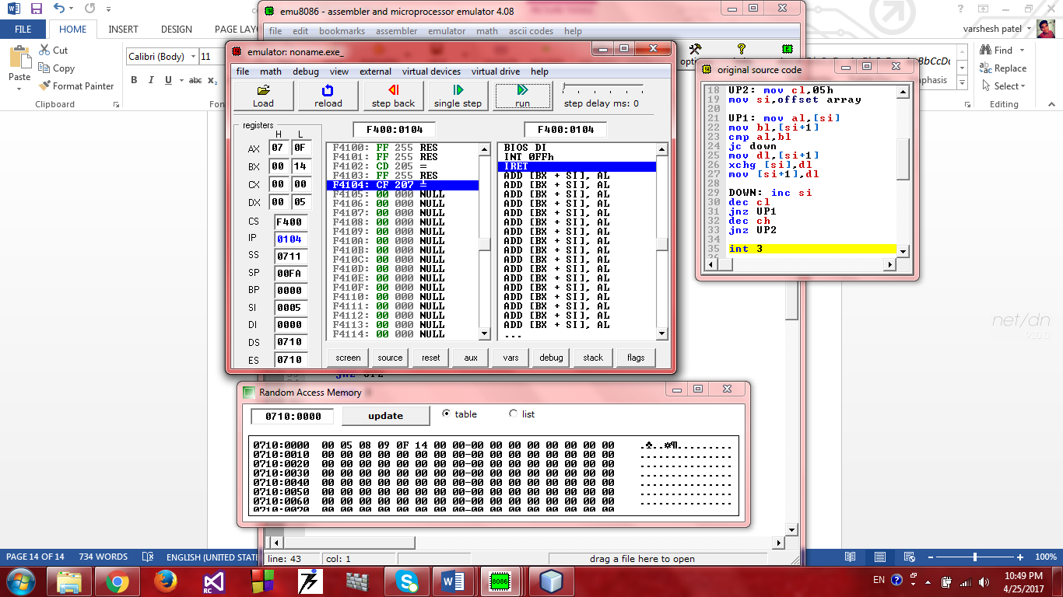

**Experiment No.9**

**Aim:** To interface LEDs on I/O port of 8086.

**Code:**

; multi-segment executable file template.

data segment

segdata db 00h,01h,02h,03h,04h,05h,06h,07h,08h,09h

ends

stack segment

dw 128 dup(0)

ends

code segment

; set segment registers:

start:

mov ax,data

mov ds,ax

l3:

mov si,offset segdata

l2:

mov al,[si]

out 0f6h,al

call delay

cmp si,009h

je l3

inc si

jmp l2

proc delay near

push cx

mov cx,43h

l1:nop

nop

loop l1

pop cx

ret

endp

mov ax, 4c00h ; exit to operating system.

int 21h

ends

**Output:**

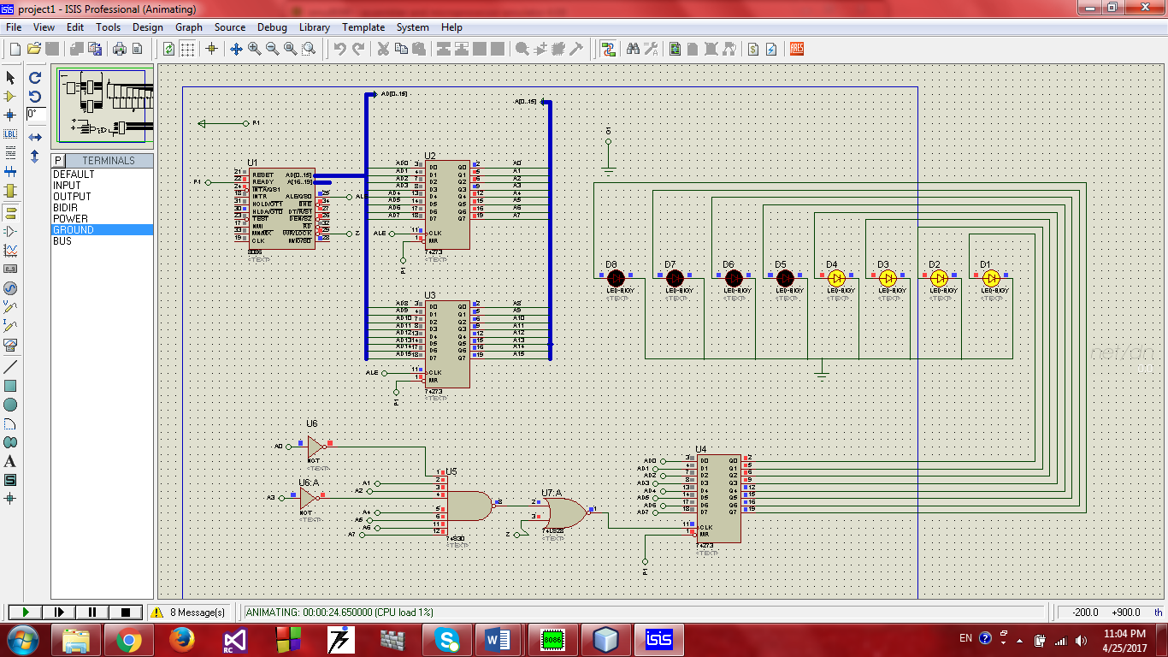

Data and address separator



Address selection



Led’s for data -> 0fh

**Experiment No.10**

**Aim:** To display 0-9 on a 7-segment display.

**Code:**

data segment

segdata db 03fh,06h,05bh,04fh,066h,06dh,07dh,007h,07fh,06fh

ends

stack segment

dw 128 dup(0)

ends

code segment

; set segment registers:

start:

mov ax,data

mov ds,ax

mov si,offset segdata

mov cx,0ah

seg1:

mov al,[si]

out 92h,al

call delay

inc si

loop seg1

loop start

proc delay near

push cx

mov cx,43h

l1:nop

nop

loop l1

pop cx

ret

endp

mov ax, 4c00h ; exit to operating system.

int 21h

ends

**Output:**

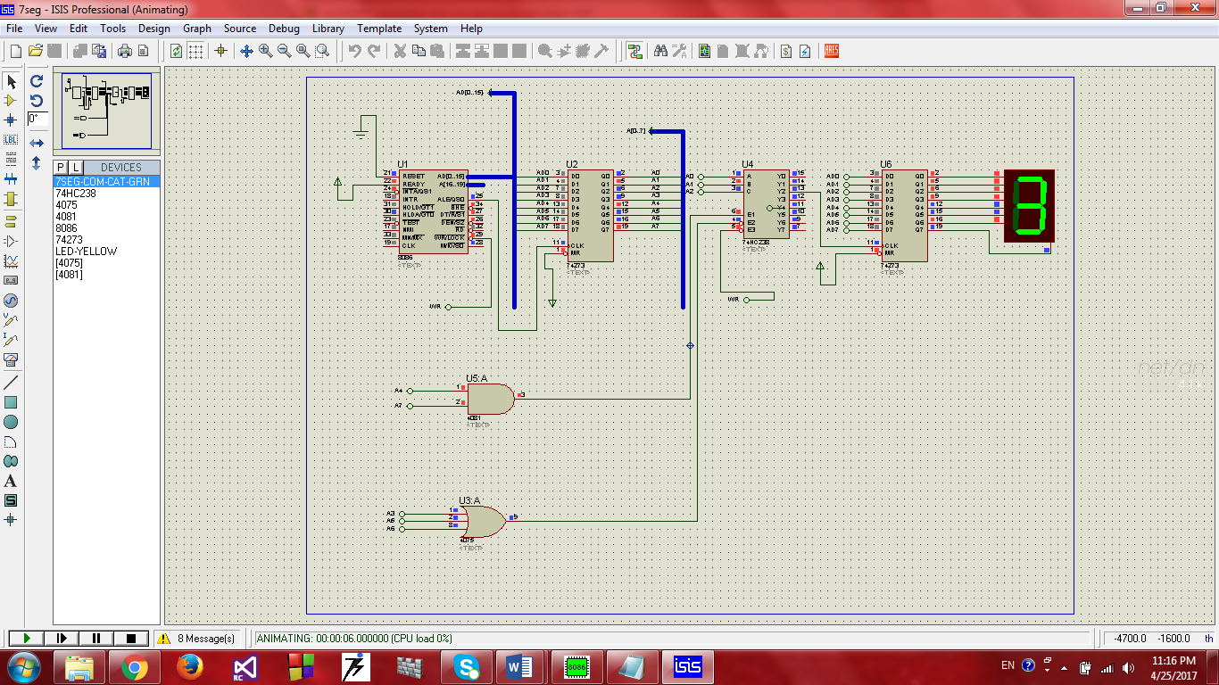

**Experiment No.11**

**Aim:** To display Clock(MM:SS) on a seven segment display.

**Code:**

; multi-segment executable file template.

data segment

msg1 db:0x3f,0x06,0x5b,0x4f,0x66,0x6d,0x7d,0x07,0x7f,0x6f,0x77,0x7c,0x39,0x5e,0x79,0x71

ends

stack segment

db 256 dup(0)

ends

PortA EQU 90H ; Port A's port number in I/O space

PortB EQU 92H ; Port B's port number in I/O space

PortC EQU 94H ; Port C's port number in I/O space

CtrlPT EQU 96H

code segment

start:

; set segment registers:

mov ax,data

mov ds, ax

mov si,offset msg1

;mov es, ax

l3:mov dx,0000h

mov bx,0000h

mov ah,00h

mov al,80h

out ctrlPT,al

mov cx,250

jmp l2

l1:mov cx,250

inc bh

cmp bh,0ah

jb l2

mov bh,00h

inc dl

cmp dl,06h

jb l2

mov dl,00h

inc dh

cmp dh,0ah

jb l2

mov dh,00h

inc ah

cmp ah,06h

jb l2

jmp l3

l2:mov bl,bh

push bx

mov bh,00h

mov AL,00001110b

out PORTA,AL

mov al,[si+bx]

out PORTB,AL

call delay

mov bl,dl

mov AL,00001101b

out PORTA,AL

mov al,[si+bx]

out PORTB,AL

call delay

mov bl,dh

mov AL,00001011b

out PORTA,AL

mov al,[si+bx]

out PORTB,AL

call delay

mov bl,ah

mov AL,00000111b

out PORTA,AL

mov al,[si+bx]

out PORTB,AL

call delay

pop bx

loop l2

jmp l1

hlt

proc delay near

push cx

mov cx,41

l4: nop

nop

loop l4

pop cx

endp

ret

; wait for any key....

;mov ah, 1

;int 21h

;mov ax, 4c00h ; exit to operating system.

;int 21h

ends

end start ; set entry point and stop the assembler.

**Output:**

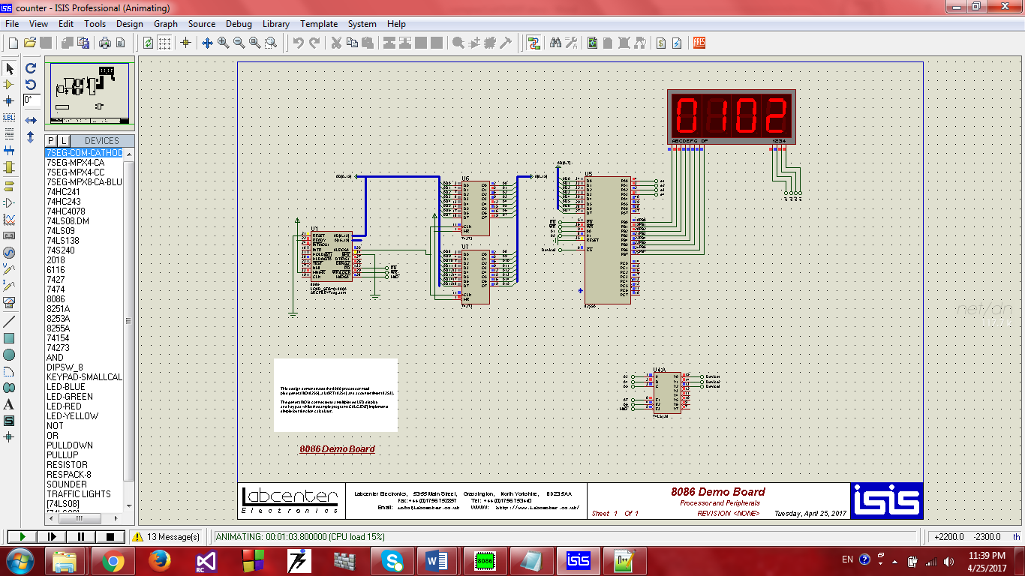

**Experiment No.12**

**Aim:** To display a message on 16x2 LCD.

**Code:**

data segment

; add your data here!

cmd db 01h, 06h, 0Eh, 38h, 80h, 00h

data1 db "Welcome", 00h

cmd1 db 0c0h,00h

data2 db "4IT", 00h

ends

code segment

start:

; set segment registers:

mov ax, data

mov ds, ax

mov al, 80h

out 8eh, al

start1:mov si, offset cmd

l1:

call sendcommand

mov al, [si]

cmp al, 00h

je l2

jmp l1

l2:

mov si, offset data1

l8:

call senddata

mov al, [si]

cmp al, 00h

je l4

jmp l8

l4:

mov si,offset cmd1

l5:

call sendcommand

mov al, [si]

cmp al, 00h

je l6

jmp l5

l6:

mov si, offset data2

l7:

call senddata

mov al,[si]

cmp al, 00h

je start1

jmp l7

proc sendcommand near

mov al, [si]

out 82h, al

mov al, 00000010b

out 86h, al

call delay

mov al, 00000000b

out 86h, al

inc si

ret

endp

proc delay near

mov cx, 43

l3:

nop

nop

loop l3

ret

endp

proc senddata near

mov al, [si]

out 82h, al

mov al, 00000011b

out 86h, al

call delay

mov al, 00000001b

out 86h, al

inc si

ret

endp

ends

end start ; set entry point and stop the assembler.

**Output:**

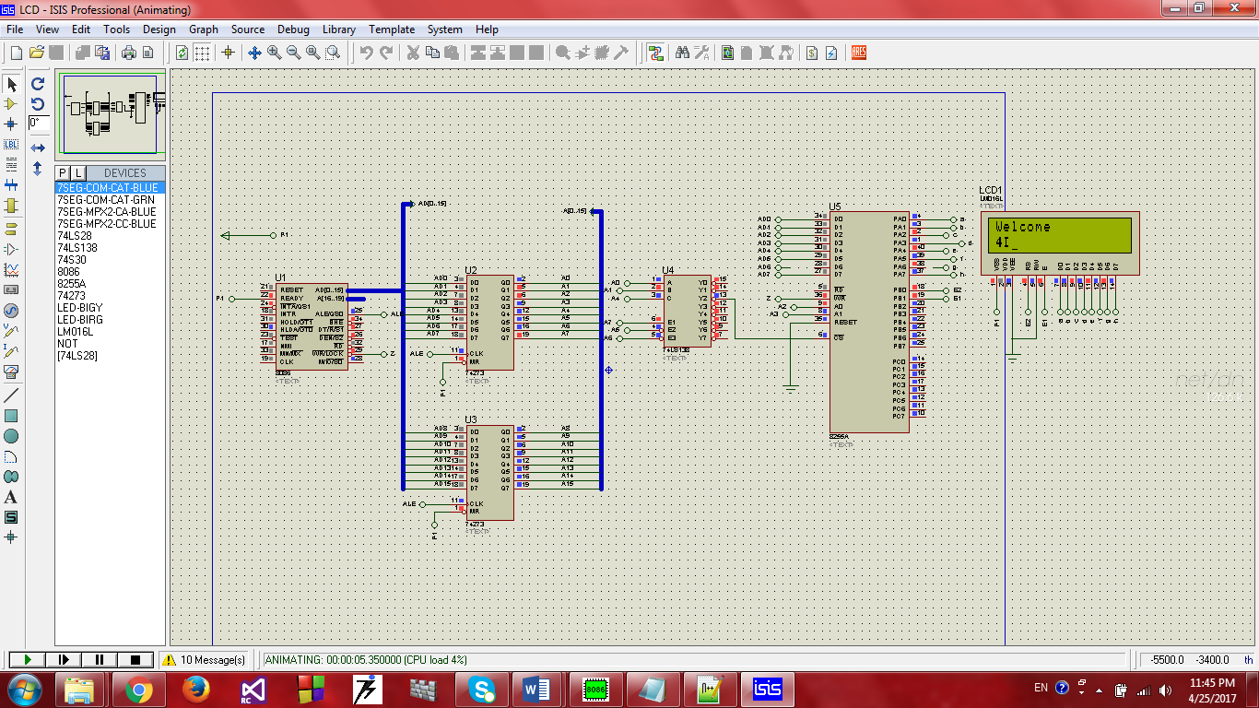



Lcd 16x2

**Experiment No.13**

**Aim:** To interface DC Motor on I/O port of 8086.

**Code:**

org 100h

START:

mov al,0F1h

out 80h,al

call delay

mov al,00000010b

out 80h,al

JMP START

ret

proc delay near

push cx

mov cx, 1920d

l3:

nop

nop

loop l3

pop cx

ret

endp

**Output:**

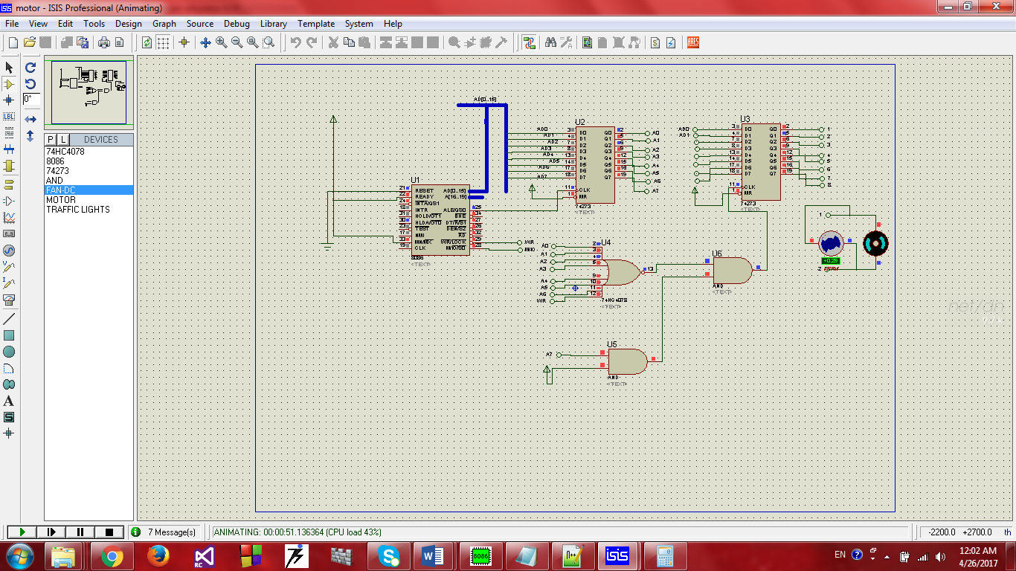

**Experiment No.14**

**Aim:** To interface ADC0804 and display current temprature on 7-Segment display.

**Code:**

data segment

msg1 db 0x3f,0x06,0x5b,0x4f,0x66,0x6d,0x7d,0x07,0x7f,0x6f

ends

PortA EQU 90H

PortB EQU 92H

PortC EQU 94H

CtrlPT EQU 96H

code segment

start:

; set segment registers:

mov ax,data

mov ds, ax

mov si,offset msg1

;mov si,offset msg1

;mov es, ax

mov bh,00h

mov dl,00h

mov al,82h

out ctrlPT,al

l1: in al,PortB

mov dl,al

call display

jmp l1

proc display near

mov cx,250d

l2:mov al,dl

mov bl,0ah

mov ah,00h

div bl

mov bl,al

mov AL,00000001b

out PortC,al

mov al,[si+bx]

out PortA,al

call delay

mov bl,ah

mov al,00000010b

out PortC,al

mov al,[si+bx]

out PortA,al

call delay

loop l2

ret

endp

proc delay near

push cx

mov cx,86

l4: nop

nop

loop l4

pop cx

ret

endp

; wait for any key....

;mov ah, 1

;int 21h

;mov ax, 4c00h ; exit to operating system.

;int 21h

ends

end start ; set entry point and stop the assembler.

**Output:**

